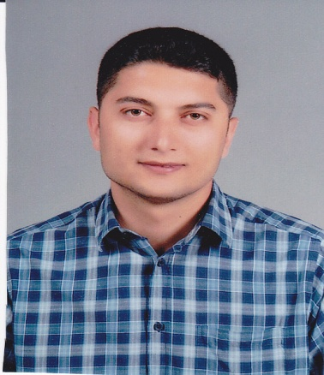

Lecturer Ercüment Yaşar

PERSONAL INFORMATION ercu04@gmail.com

Address: Yakuplu Mahallesi 146. Sokak No:9 Daire: 10 Beylikdüzü / İstanbul
Phone Number: 0554 426 83 65
Military Service: Postponed (01/09/2021)

EDUCATION

01.09.2015: PhD. , İstanbul Aydın University, English Language and Literature (Class Period Completed)

2012- 2014: MA, Fatih University, English Language and Literature

2005-2009: BA, Dumlupınar University, English Language and Literature

2001-2005: Torbalı Anatolian High School, Foreign Languages Class

MASTER’S THESIS

Representation of the Contemporary British Middle Class in Ian McEwan’s Novels Saturday and

Solar

Supervisor: Assistant Professor Doctor Agnes E. Brandabur

PUBLISHED ARTICLES

Yaşar, Ercüment. (2013) The Eastward Expansion of the British Middle Class in the Post-Cold

War Era: “In the Context of Ken Loach’s It is a Free World” Civilacademy Journal of Social

Sciences 10: 1-11.

Yaşar, Ercüment. (2015) The Alienation of the First Generation of the Post-War British Society in

Light of Look Back in Anger by John Osborne. The International Journal of Media, Culture and

Literature 2: 13-27.

WORK EXPERIENCE

17.03.2014- …………….: Lecturer / İstanbul Aydın University Applied English and Translation

Department

04.11.2013- 17.06.2014: English Teacher / Sarıyer Lifelong Education Centre (Sarıyer- İstanbul)

13/02/2013 - 14/06/2013: English Teacher / İstinye Cevat Koçak High School (Sarıyer-İstanbul)

0106/2011 - 31/01/2012: Tourist Guide / Dikili Municipality Tourism Information Office (Dikili-

İzmir)

SCORES

ALES 2016 Spring Term: 82,71948

YDS 2014 Spring Term (Language Exam): 87.500

FOREIGN LANGUAGE

English: Advanced

COURSES

Academic  Year | Term | Course | Weekly
 |  |  | Teory | Practice | Student
2013-2014 | Spring | ING102 English-II | 3 |  | 272
 |  | SKI242 Business English-II | 3 |  | 38
 |  | ING202 Business English-II | 3 |  | 69
2014-2015 | Fall | ING101 English-I | 3 |  | 400
 |  | GRF243 Business English-I | 3 |  | 24
 | Spring | ING202 Business English-II | 3 |  | 27
 |  | ING102 English-II | 3 |  | 260
 |  | SKI242 Business English-II | 3 |  | 59
2015-2016 | Fall | ING101 English-I | 3 |  | 256
 |  | ING201 Business English-I | 3 |  | 54
 | Spring | ING102 English-II | 3 |  | 286
 |  | SKI242 Business English-II | 3 |  | 59
 |  | ING202 Business English- II | 3 |  | 54
2016-2017 | Fall | ING101-English-I | 3 |  | 214
 |  | ING201-Business English-I | 3 |  | 64
 |  | MIR219-Business English-I | 3 |  | 45

