CURRICULUM VITAE
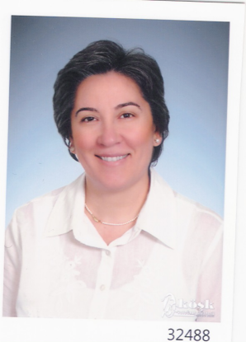
1. Name Surname : Tülay Akbay
2. Birth Date : 24.01.1962
3. Title : Lecturer
4. Education :Masters /Ph.D. Continuing

Degree | Major | University | Year
Bachelor | Educational Faculty , Department of English Language Teaching | Çukurova University | 1984
Masters | Curriculum and Instruction (TEFL) | University of Kansas | 1988
Bachelor | Economics Faculty | Open University | 2016
Associate Degree | Justisce Vocational College | Open University | 2018
Ph.D | Sociology | İstanbul University | Thesis Phase

5. Academic titles and other working positions:
Instructor: Erciyes University, 1984-1999
Assistant Coordinator: Erciyes University
Instructor: Mersin University, 1999-2008- Retired
Instructor: Kültür University, 2008-2009
Instructor: Commerce University, 2010-2011, Part-time
Lecturer: Beykent University, 2011 - 2013
Instructor: Acıbadem University ,2013 – 2015
İstanbul Aydın University, 2016- ……
6. Assisted Masters and Ph.D. Thesises
6.1. MastersThesis: An Integrated Syllabus Design For Intensive Reading And Writing Courses In Turkey
6.2. Ph.D. Thesis: Emergence and Institutionalization of Micro Sociology in the USA
7. Publications

7.1. International Cited Journals (SCI & SSCI & Arts and Humanities): -
7.2. International Presentations and Proceedings: -
7.3. Books or chapters in international publications (Proceedings) : --
7.4. International workshops that are coordinated: -
7.5. National cited journals: -
7.6. National presentations and proceedings: -
7.7. Abstracts that are accepted for international presentations: -
7.8. Other publications on journals: -
8. Projects: ---

9. Meetings and Organizations:
Fulbright Seminar at Robert College, 1986 ( 6 weeks )
TESOL Convention. Chicago, 1988 (1 week )
10. Registered memberships to Scientifc and Vocational Associations: -
11. Awards:
Student of Honor ( Çukurova University -1984 )
Fulbright Scholarship (Masters )
Kansas University Ph.D Scholarship

12. Courses of previous two years for under and post graduate studies:

Academic Year | Term | Name of the Course | Weekly Course Number |  | Number of Students
 |  |  | Theoretic | Practice
2016-2017 | Fall | Prep Department  Coursebook | 12 |  | 24
 |  | Reading  Writing  Listening | 4  4  4 |  | 24  24  24
 | Spring | Prep Department  Coursebook | 12 |  | 24
 |  | Reading  Writing  Listening | 4  4  4 |  | 24  24  24
2017-2018 | Fall | Prep Department  MEC | 4 |  | 24
 |  | Reading  Listening | 4  4 |  | 24  24
 | Spring | Prep Department  MEC | 4 |  | 24
 |  | Reading  Listening | 4  4 |  | 24  24

