EYLUL PINAR KISA
eylulpinarkisa@gmail.com  eylulkisa@aydin.edu.tr |  | Sex: female  Birth Date: 07/09/1993  Marital Status: Single  Nationality: Turkey  Physical Therapist | 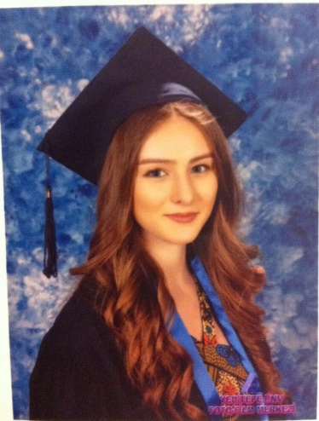

OBJECTIVE
Catching a value adding career opportunity in the light of my education and career background.

EDUCATION
Postgraduate(master) | Hasan Kalyoncu University – İstanbul –Physical Therapy and Rehabilitation 2016-2017
University | Yeditepe University – İstanbul –Physical Therapy and Rehabilitation–  2011 – 2016

WORK EXPERIENCE
01/2017 – Working | Osteolife Healthy Life Center

ADDITIONAL EDUCATION & CERTIFICATES
Education
05.2017 Schroth Scoliosis Therapy

02.2017 APPI Clinic Pilates (matwork level 1)

12.2016 Matrix rhythm therapy (marhy-rhythmus
therapie) (MUNIH)

02.2016 Manuel assessment and treatment tecnics in spinal
cord
02.2016 Upper and lower extremity Manuel assessment and
treatment tecnics
02.2016 Kinesiotape 1

02.2016 Lymph edema banding

02.2016 Patient Focused Compression Applications in the
Treatment of Lymphadenopathy

11.2015 Foot-Ankle Clinical and Functional Evaluation

10.2015 Occupational health and safety training

04.2014 Rigid banding on foot

Certificates
03.2017 Current Approaches in Parkinson Disease
12.2016 Obstetric Brachial Plexus Treatment
10.2016 Current Approaches in Rheumatologic Diseases
10.2016 2nd National Rheumatological Rehabilitation Congress
03.2016 Neurological Physiotherapy Symposium
(Physiotherapy and Rehabilitation Approaches in Muscle
Tone Disorders)
04.2016 Istanbul Physiotherapy and Rehabilitation Days
Symposium
05.2016 1st Orthopedic Rehabilitation Symposium
02.2016 6th International Congress of Cerebral Palsy and
Developmental Disorders
11.2015 8th National Sport Physiotherapists Congress
(Rehabilitation in Muscle-Tendon-ligament Injuries)
10.2015 3rd Pediatric Rehabilitation Congress
04.2016 Istanbul Physiotherapy and Rehabilitation Days
Symposium
04.2015 3rd National Physiotherapy and Rehabilitation Student
Congress (Participant and Congress Officer)

Academic study
Lısance Completed Thesıs: Evaluation Knee Joint Q Angle and Postural Stability Pes Planovalgus Deformity in Children with Juvenile Idiopathic Arthritis
Yeditepe University Completion Thesis Poster Presentation
Istanbul University 2nd National Rheumatological Rehabilitation Congress

LANGUAGE SKILLS
English | Reading: Advanced, Writing: Advanced, Speaking: Good

